**LAB-08**

**Configure the following scenario by applying static routes in eNSP.**

**Note: All routers should be able to ping all interfaces.**

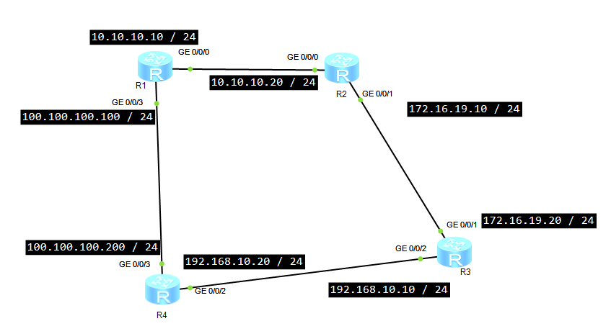**eNSP simulation:**

**First, we have to assign the Ip address to each interfaces then we have to configure these commands on routers.**

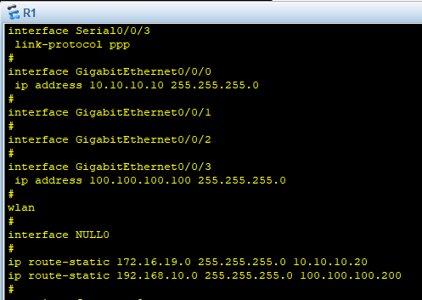**Configuration on Router (R1):**

**IP Routing Table:**

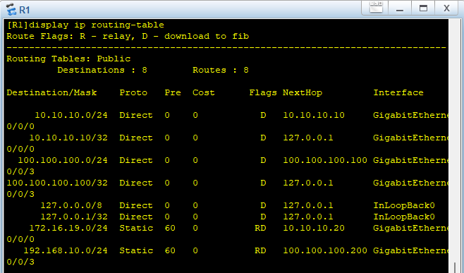

**Configuration on R2:**

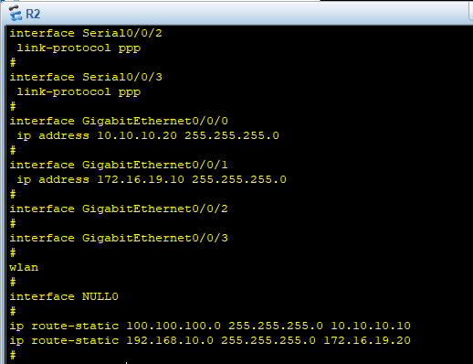

IP Routing Table:

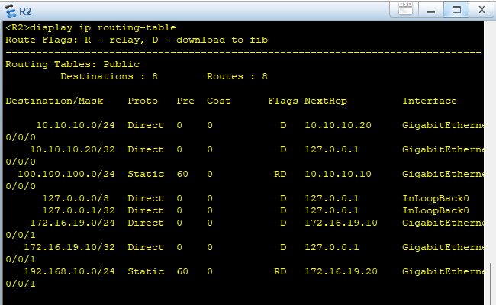

Configuration on R3:

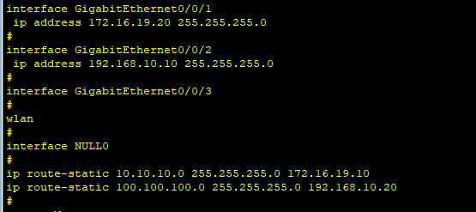

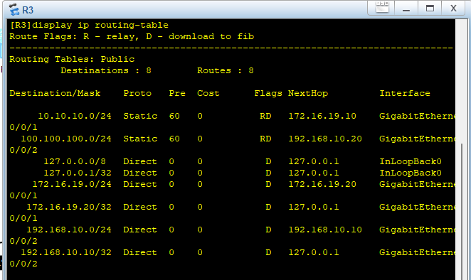IP Routing Table:

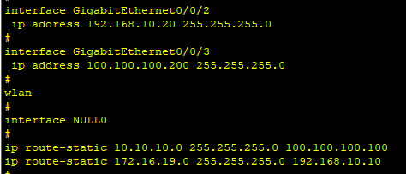Configuration on R4:

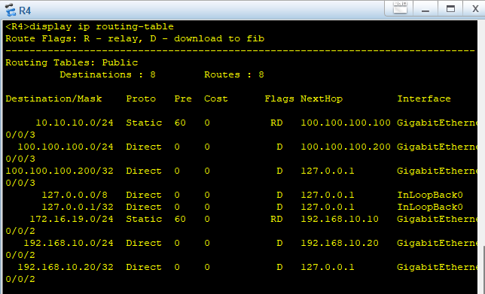IP Routing Table:

s **TESTING:**

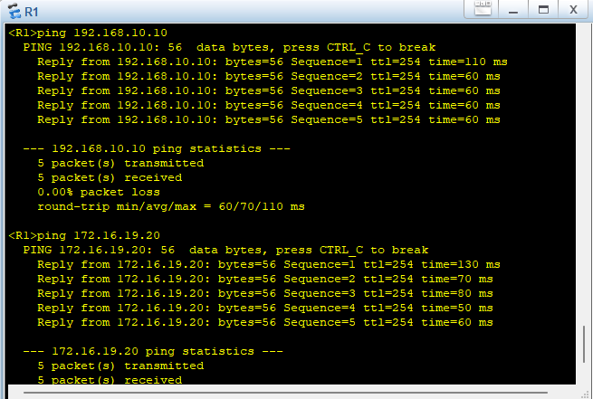**R3 FROM R1:**

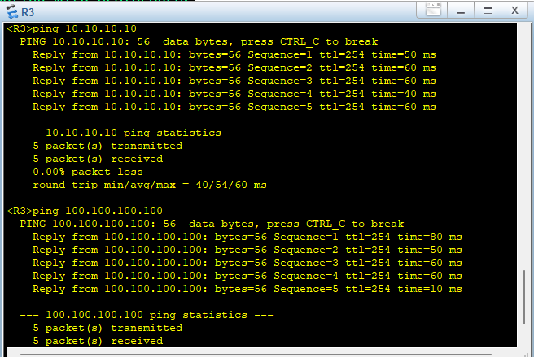**R1 FROM R3:**

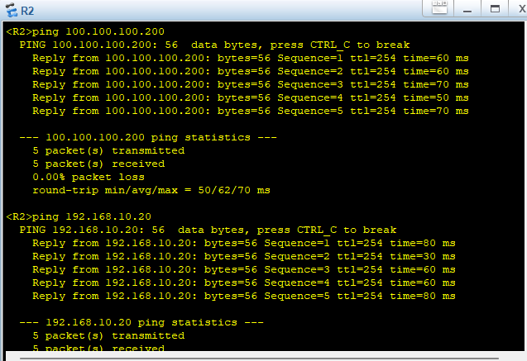**R4 FROM R2:**

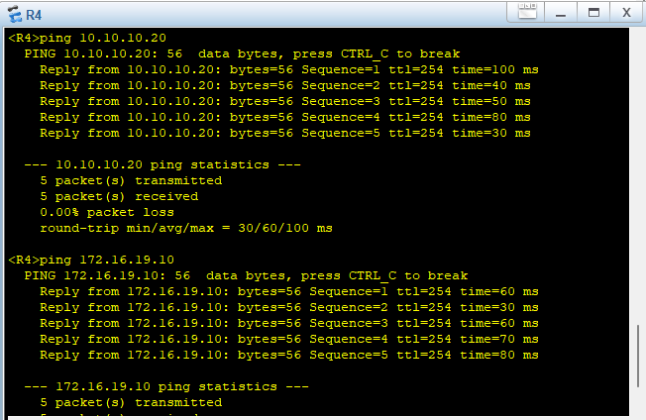**R2 FROM R4:**